TestLink Development Environment Setup For Windows
2/19/07
Author - kevinlevy@hotmail.com

This document does not replace documentation for production installation.
I used this process to get a TestLink development environment up on Windows as easily as possible. This will allow you to quickly debug or build code that will be used in your local installation of TestLink. Tools used are very common and have sufficient online documentation available. It allows you to stay synchronized with tip-of-tree code from all branches.

e-novative WAMP (includes MySQL database, apache, and PHP extension)
I found this tool to be one of the better WAMP install tools due to ease of installation, admin tools , and plug-in support.
Download installation and follow the simple installation wizard :
http://www.e-novative.info/software/wamp/wamp_download.php

Eclipse (development environment) – download the latest SDK (software development kit) from http://www.eclipse.org/downloads/
(I am using eclipse SKD 3.2 as of 2/19/07)

PHP Plugin for Eclipse - http://sourceforge.net/project/showfiles.php?group_id=57621
(I am using using phpeclipse-1.1.8 as of 2/19/07)

Eclipse SourceForge CVS Integration
This allows you to keep your dev environment synced with CVS.

Here is an “official Eclipse CVS integration site” - http://www-128.ibm.com/developerworks/opensource/library/os-ecshare/

Here are the steps to get up and running quickly:
- launch eclipse
- select “window” -> “show view” -> “CVS Repositories”
- A CVS Repositories pane should pop-up
- Right click inside this pane and select “New -> Repository Location”
- In dialog fill in :
Host = testlink.cvs.sourceforge.net
Repository Path = /cvsroot/testlink
User = anonymous
Authentication = leave blank for anonymous user (devs will have their own password)
Connection Type = pserver (devs use extssh)
“Use default port” should be checked
“Validate connection on finish and save password” should be checked

Once completed – you should see the repository added the CVS Repository window. You will now be able to checkout code from TestLink CVS.

Creating a TestLink Project in Eclipse

1. Create directory in your file system:

Assuming you installed e-novative at
Where C:\Program Files\e-novative\

C:\Program Files\e-novative\WAMP\www\testlink

2. Create PHP project – File -> New Project

3. In the project wizard choose “PHP Project”

4. Wizard will start – fill out as:
Project name = testlink
Uncheck “use default location”
Location = C:\Program Files\e-novative\WAMP\www\testlink
Click Finish

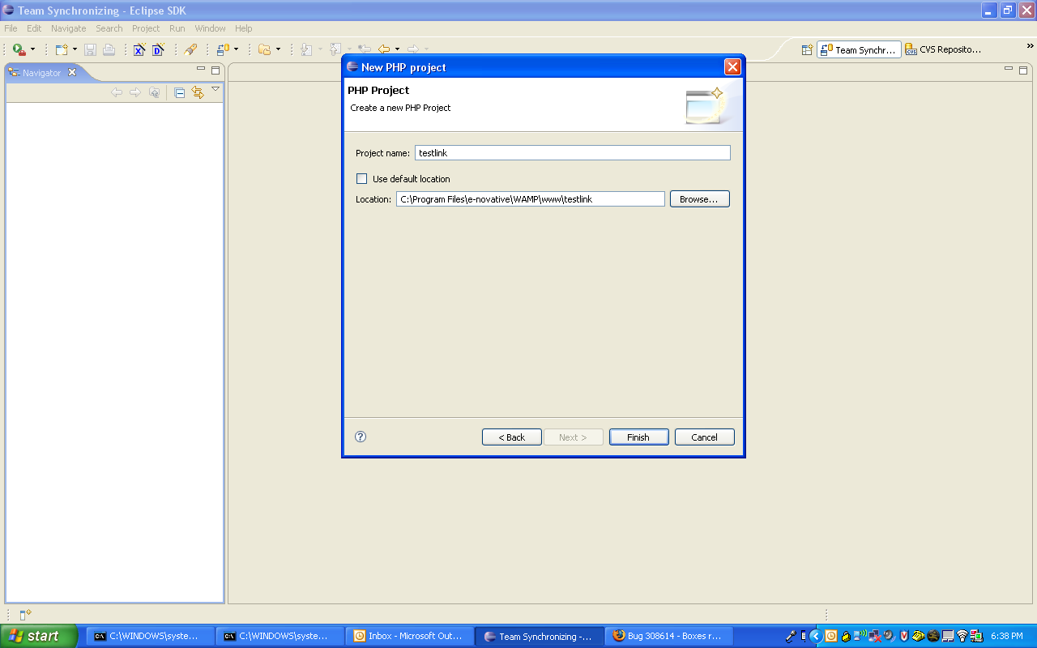

5. Project will be displayed. Right – click on top level folder in Navigator view and click “import”.

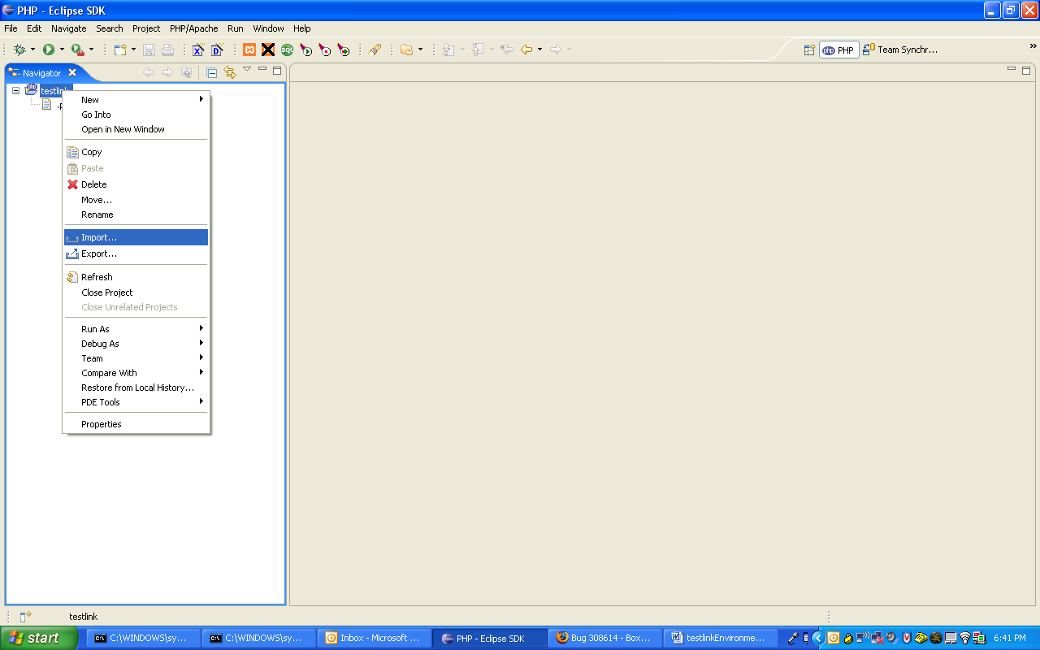

6. Select import source = CVS – Projects From CVS and click next

7. select :extssh:kevinlevy@testlink.cvs.sourceforge.net:/cvsroot/testlink – click next

8. select “use specified module name: “ radio button and enter “testlink” in the text field.
Select Next

9.
Select “check out as a project in the workspace”
Project name = “testlink”
Be sure “checkout subfolders” is checked.
Select Next

10. On the next site
“use default workspace location” should be checked
Location should be set to
C:\Program Files\e-novative\WAMP\www\testlink
Select next

11.
Tag name field should be blank
Select “HEAD” for the Matching tags
Select Finish

12. checkout will begin
It may ask “The resource ‘testlink’ already exists in the workspace and will be deleted. Proceed with checkout of testlink?”
Select OK

